How-To Guide
Sacramento County ECE Cost Modeling Survey

Before you begin
Plan for about 60 minutes to complete the survey. You can save your work and come back later. If you can, have your 2025 financial, payroll, enrollment, and operating records nearby.

Choose your language
At the start of the survey, choose your preferred language. Click the circle next to the language you want to use.
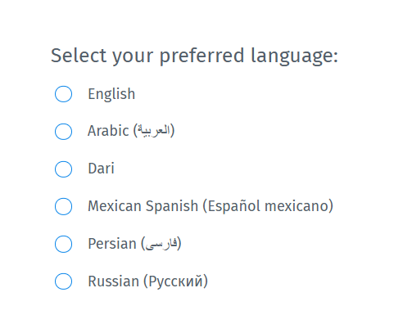

Show that you are not a robot
The survey uses a security check called reCAPTCHA.
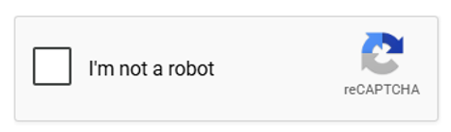
Click the box that says “I’m not a robot.”
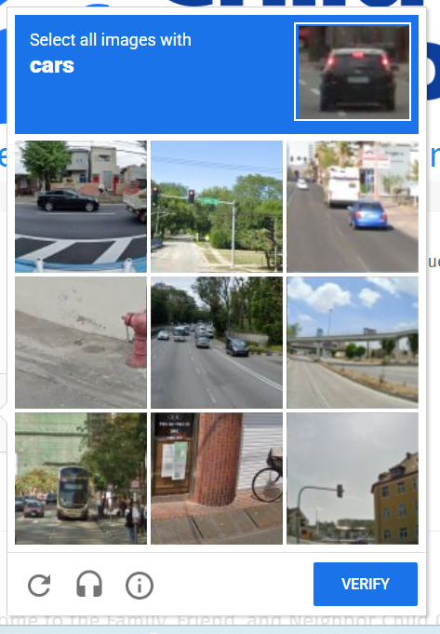
- You may see a picture question. Follow the directions on the screen.
- Click the pictures that match the directions.
- Then click “VERIFY.”
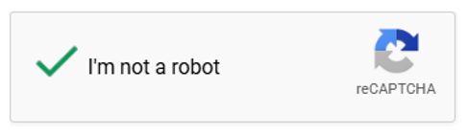

Move through the survey
Use the buttons at the bottom of each page to move through the survey.

- Click “Next” to go forward to the next page.
- Click the back arrow to return to the previous page.
- If you need a break, choose “Save & Continue Later”.

Save & Continue Later
If you need to stop before finishing the survey, you can save your answers and come back later.
- Click “Save & Continue Later”, found at the bottom of each page.
- Enter your email address when asked.
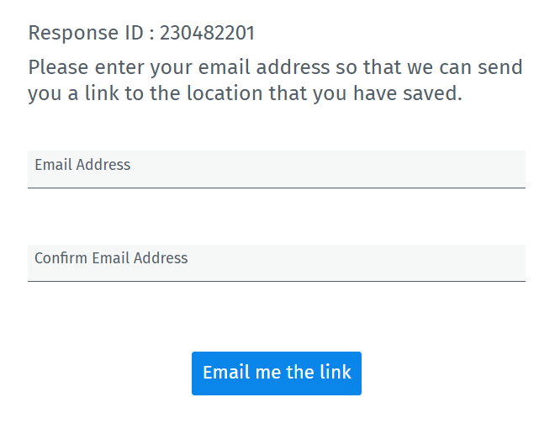
- QuestionPro will send an email with a link to return to your survey.
- When you are ready to continue, check your email and click the link.
Tip: If you do not see the email, check your spam or junk folder.

Know which questions you must answer
A red star (*) means the question is required. You need to answer it before you can move on.
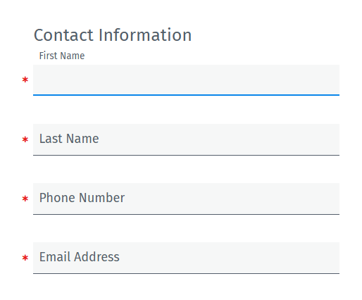

Understanding the Questions
You will see different types of questions as you move through the survey.
- If you see a circle next to the answers, choose the one answer that best fits your program.
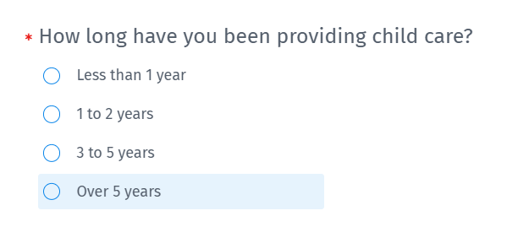
- If you see a square next to the answers, you can choose more than one answer if they apply to your program.
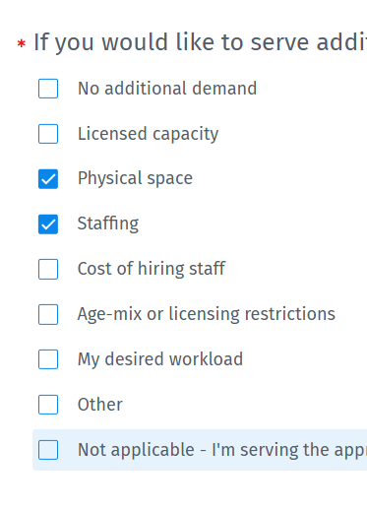
- Some questions use a table. If the table is required, you need to enter an answer in each section that applies to you. If a section does not apply to your program, enter 0 (zero).
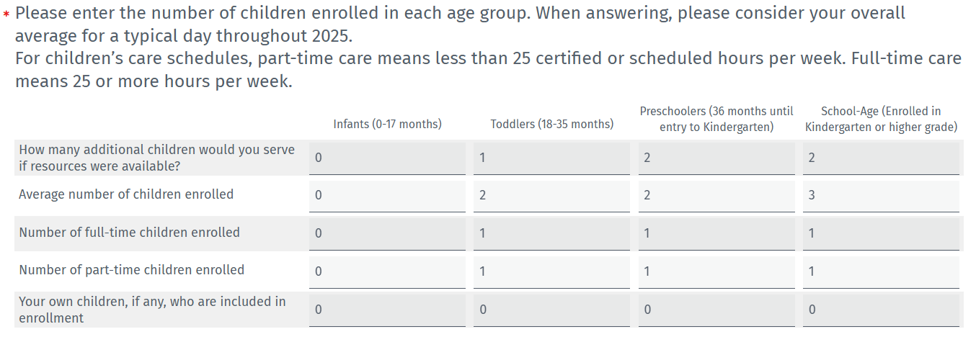
Example: If a table asks about the number of children in different age groups and you do not care for infants, enter 0 for infants.

Review before you finish
Please review before you finish. Use the back button if you need to check or edit any answers from previous pages. Once complete, click “Done.”

You’re done! Thank you for taking the time to complete the Sacramento County ECE Cost Modeling Survey.

